**Python Web App online**

**Put your Python app online**

You can get your Python website or Python (Flask) app online in 2 minutes!

The process is quite easy.

First sign up on [**PythonAnywhere**](https://www.pythonanywhere.com/?affiliate_id=00535ced). Then click on the “Open Web Tab”.

Click on “Add a new web app”. Then click next. You’ll be presented with several Python web frameworks you can choose from.

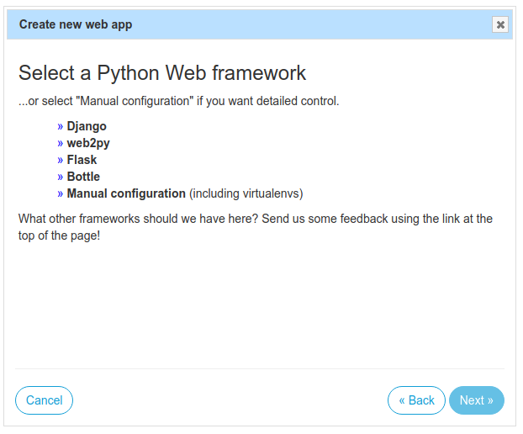

Select Flask and click next. If you want to, you can change the project’s directory.

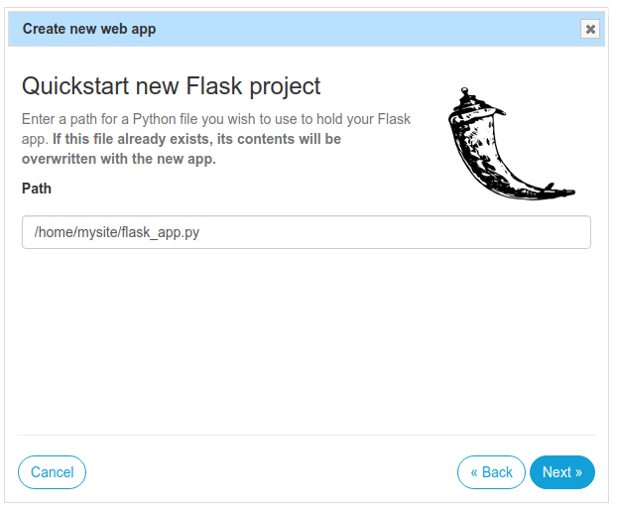

Then select your Python version. If you don’t have any legacy, pick the newest version.

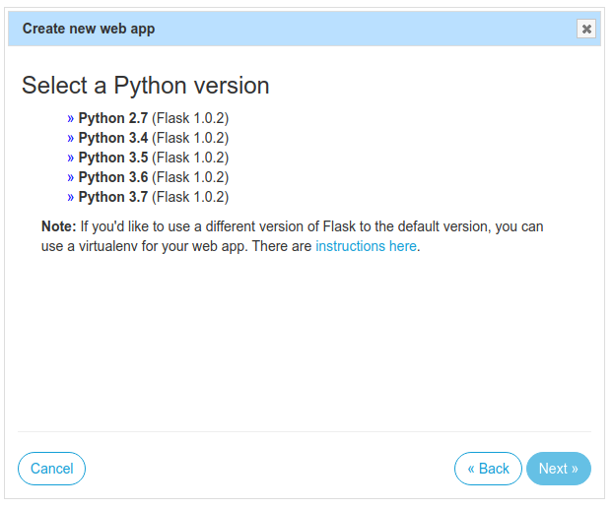

Then click next. You can optionally change your app name.

Click next

Now your Python Flask web app is online! Click on the green button, your website will then show.

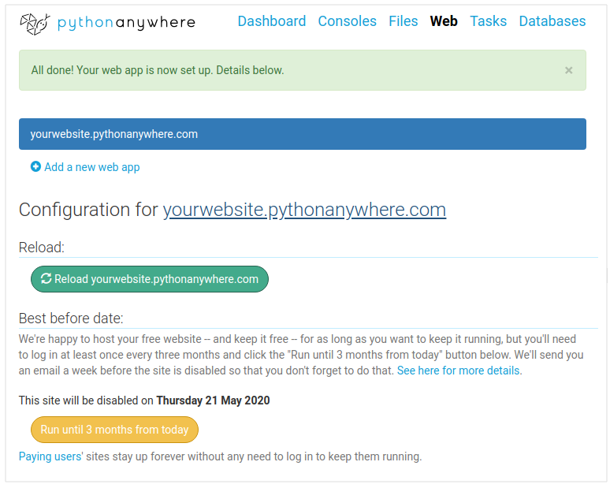

You can change your website from the bash console, or if you want you can edit it straight from your browser.

That’s it, that’s how easy it is to put your Python Flask App online.

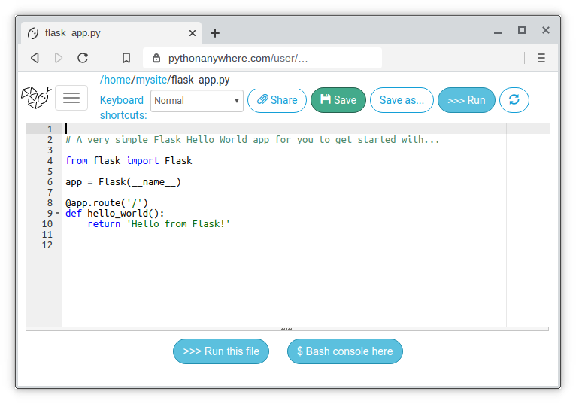

From here you can use the built-in browser-based editor, Bash consoles,you can use git, mercurial and other VCS’s to push and pull your code.